1. **Job ad analysis (in-class)**

On the left, list the skills, concepts, and keywords from your job ad. On the right, brainstorm about your experience and expertise that qualifies you for the particular requirement listed on the left. For example, on the left you might have “excellent communication skills” and on the right you could list “A+ in EAC397,” and “Work experience in PR department at Dell.”

* You might not have a corresponding experience for all the job ad requirements
* You don’t need to list every work experience you’ve had – just the ones relevant to the ad
* You can include more than one example of your experience for each qualification required

|  |  |
| --- | --- |
| **Skills, concepts, keywords from job ad** | **Evidence of your qualifications** |
| Support experience design, functional requirements and digital product definition by providing technical solutions  Plan and estimate development tasks   * Develop and maintain comprehensive architecture designs and technical documentation | Analyzed/designed/documented/developed/tested Java/Web-based complex business process systems  And customers’ service requests  Worked as a member of POSCO MES maintenance team.   * managed the official technical specification |
| Define an integrated, RESTful, JSON Schema standards | Developed Angular/RESTful API/Node.js College projects with A+ |
| Participate in daily delivery SCRUMs to ensure Sprint delivery progression and resolution of issues | * Worked as a member of POSCO MES maintenance team. * Analyzed/designed/documented/developed/tested the Java and SQL-based source codes according to the customers’ service requests of 4 factories in Korea and 1 factory in Indonesia, to improve the systems and enhance business processes * Monitored/debugged system faults in remote-area using VPN software to support 24/7 non-stop system * Reported the impacts of the system changes to support the system project teams |
| Conduct unit testing on developed code, with automated testing where relevant | Participated in all test stage from unit test ~ integration test ~ customer test and so on using QA system   * write port, patched, |
| * Participate in group and peer code review session   Actively involved during QA triage to recommend and provide fixes | Used code checker program (RESORT) to improve and keep consistency of source codes  Responded QA team’s recommendation in code convention and enhance security vulnerability |
| * Assist incident management teams by troubleshooting and resolving production incidents | Monitored/debugged system faults in remote-area using VPN software to support 24/7 non-stop system |
| Mentor and train other developers   * Provide technical expertise to make code design and implementation decisions | Educated technical skills and business process to junior developers |
| Solid knowledge (7+ years) in J2EE/JEE software delivery or software development including multiple frameworks such as Hibernate, Spring MVC, Spring Security, SAML, OAuth, OIC | (7+ years) in J2EE/JEE/Spring MVC, Spring Security  Spring MVC  Client-session.js, bctype.js instead of Spring Security  Oracle MVC framework  Oracle Application Developing Framework  Oracle SSO vs SAML/OAuth/OIC |
| Proven experience in API management tools, like MuleSoft API Manager (preferably) or Apigee Edge |  |
| 2+ years of hands-on experience building RESTful/SOAP API solutions | RESTful API (Node.js, Angular, React) |
| Experience with SQL Server database, SQL and T-SQL | Oracle/MySQL/PostgreSQL/MongoDB/DB2/SQL server |
| Previous working experience with Mule ESB or MuleSoft Anypoint Platform is a definitive plus |  |
| Experience with Unit Testing frameworks and tools (Junit, MUnit or TestNG) and source control software (CVS, SVN, Git or similar) | GIT/Serena Version Manager (PVCS)  Jasmin/Angular testing tool |
| Experience working in financial industry and knowledge of banking products is a definite asset | Manufacturing Industry |

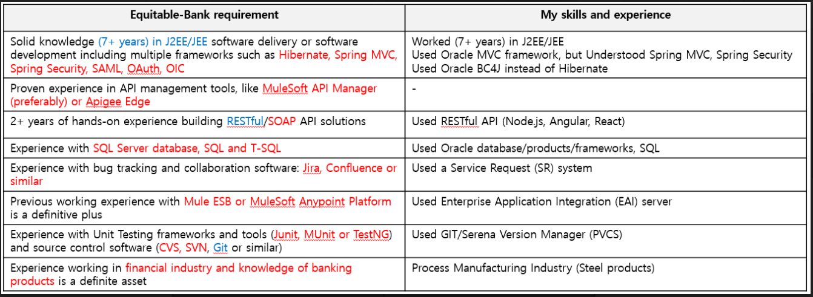

* Note: You should add rows to this table if you need more space for additional keywords.

|  |
| --- |
| 1. **Considering the left column, what does the essential need of this company seem to be?**   This company requires various professional skills and attitudes. As IT skills, Java (5+ years), SQL (RDBMS), Javascript, JQuery, AngularJS and BootStrap, HTML / CSS, J2EE, REST, JSON, Oracle Specific (ADF, BC4J), ERP are required, but Java skill is the most asset. Also, this company requires the analyzing, designing, and documenting ability for customers’ requests. Moreover, in this company, cooperating with clients, peers, and managers are important, keeping due-date, and working multi-task are important requirements. |
| 1. **Considering the right column, where do you need more evidence of your qualifications?**   Required skills:  - Worked as a full stack web developer using Java/J2EE/Oracle SQL/JavaScript/HTML5/CSS for 10+ years  - completed 20+ professional Java web projects  - completed college projects with Angular/NodeJS REST/ JSON/JQuery/Bootstrap  - POSCO MES Renovation project was a part of POSCO Process Innovation (PI) activities, and it was the first enterprise solution to be applied Java/J2EE to large-scale process manufacturing system  - Oracle J2EE solution, Oracle Application Development Framework (OADF), Oracle Business Component for Java (BC4J), Oracle MVC-J2EE Framework  - POSPIA3.0 was a Java/J2EE/Oracle solutions/Web-based system to track the raw materials, products, and costs in POSCO global workplaces through standardization and integration of over 170 global business systems like ERP, MES, and SCM  - Analyzed/designed/developed/tested the Java/SQL-based source codes of manufacturing system related to changing POSCO ERP model to contribute accurately calculation of product cost information  - Oracle Concurrent Manager on Oracle E-Business  - graduated of the Computer Programming Developer Program with GPA: 3.9/4.0  Attitude:  - Understood big size company culture and professional project culture  - POSCO is the big size company, so there are many system technical supporting teams such as the system architecture team, the quality assurance team, and global standardization team and so on. I had to corporate with those teams and follow the company standardization.  - Then I had to work double jobs as a maintenance team member as well as the project team member.  - Completed all customers’ service requests in specified time frame  - Responded the queries of the maintenance team managers in a very short period of time  - Completed all project within the due-date  - Managed all technical specifications in standard desirable templates  - Enhanced source codes vulnerability including security parts according to Quality Assurance Team’s requests |